CTMI - Security Architecture

Introduction:
CTMI Application is essentially an web based application enabling internal and external users to access Trade Match and Trade Services information from CBOE Direct using CTMR and other Business Services exposed via Foundation Framework’s Infrastructure Services. Hence in line with CBOE Security policies this application is envisioned to provide a multi-layer security mechanism to protect CBOE information assets from unauthorized access and misuse.
Since this is an web application using MVC Struts running on a Jetty Web Server and standard login mechanism involving userid / password authentication is used. In addition a Role based authorization mechanism is used to protect various resources from unauthorized access.

Goals:
The goal of the Security Architecture is to provide the Application with
- A standard mechanism to authenticate users with userid / password login facility enforcing CBOE authentication policies of userid / password control mechanism.
- Provide a role-based authorization to access resources / perform actions on CBOE information systems.
- Provide an accountability mechanism with audit trail functionality.

Components, Processes and Architecture:
The overall security of the CTMI application is provided by two major sub-systems namely the ASMS (Application Security Management System) and Infrastructure’s Security Service facility.
- Infra’s Security Service:
- ASMS

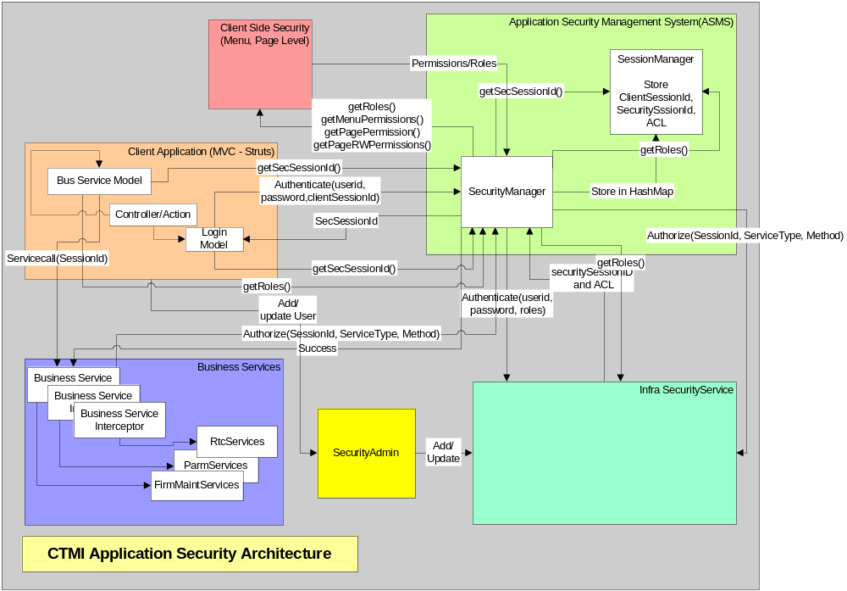
Components:
1. Security Service:
  - ACL List:
Infra’s Security Service provides a role-based mechanism to control access to various business services. An ACL list of Services and Methods is built and persisted in Infra for each Role and Users are associated with one or more roles. Depending on their role users are permitted to invoke methods on each services that are exposed to outside.
  - Interceptors:
Before calling a method on a specific service the caller is routed through a corresponding BO Interceptors that are generated for each service that is defined. The service call is made within the interceptor only after successful authorization of Service Method that is being called by that role. An Authorization Exception is thrown to the caller in case authorization fails. The authorize call to Security Service with proper parameters would accomplish this authorization.
(c)

- ASMS:
  - ASMS is the Application Security Service that provides web application the authentication and service level authorization using Infra’s security service.
  - It also provides a Session Management service that will cache Security Session Id and other relevant user info with each Client Session Id with a time-out feature.
  - ASMS consists of two components namely
    - Security Manager
      - ASMS will validate the user ID and password with the security Service
      - ASMS will provide client menu access based on the roles that a user ID belongs to

    - Session Manager
      - ASMS will maintain a memory mapping of HTTP Session ID, User ID, Security Session ID, roles and last access time
      - ASMS will provide the security session ID if the HTTP Session ID is supplied
      - ASMS will time out sessions that have been idle for a business defined period
- Client Side Security:
Client Level Security is again a role-based security and is configurable in the XML. Two Client Level Security is being envisioned.
  - Menu Level Security (Phase 1):
Menu Level Security is designed based on the Open Source Struts Menu. It is a plug-in available from Open Source Struts-Menu and is configurable by struts-menu-config.xml. The following sample shows how menus are configured in the xml. Menu/Menu Item Permissions are set by attribute values of ‘roles’ as highlighted by bolds. This way certain Menu/Menu Items are made visible or available to certain specified roles only.
In the page section corresponding actions are associated with similar roles as in Menu section for users with role to be able view/update on the screen.

// menu-config.xml
<?xml version="1.0" encoding="UTF-8" ?>

<MenuConfig>

<Displayers>
<Displayer name="DropDown"
type="net.sf.navigator.displayer.DropDownMenuDisplayer"/>
<Displayer name="MenuForm"
type="net.sf.navigator.example.PermissionsFormMenuDisplayer"/>
<Displayer name="TabbedMenu"
type="net.sf.navigator.displayer.TabbedMenuDisplayer"/>
</Displayers>

<Menus>

<!-- Menu for CTM-I -->
<Menu name="CTMIHome" title="Home" location="login.jsp" />
<Menu name="Login" title="Login">
<Item name="Login" title="Login" location="login.do" roles="CTM_Firm_Options_Root,CTM_Firm_Options_Clerk,CTM_Root,CTM_System,CTM_Help_Desk" />
</Menu>

<Menu name="FirmMaintenance" title="Firm Maintenance" location="#" roles="CTM_Firm_Options_Root,CTM_Firm_Options_Admin,CTM_Firm_Options_Clerk,CTM_Firm_Futures_Root,CTM_Firm_Futures_Admin,CTM_Root,CTM_System,CTM_Help_Desk" onmouseover="displayMenu('Firm Maintenance')">
<Item name="FirmAuthorization" title="Firm Authorization" location="firmauthorization.do" roles="CTM_Firm_Options_Root,CTM_Firm_Options_Admin,CTM_Firm_Futures_Root,CTM_Firm_Futures_Admin,CTM_Root,CTM_System,CTM_Help_Desk"/>
<Item name="FirmContactList" title="Firm Contact List" location="firmcontactlist.do" roles="CTM_Firm_Options_Root,CTM_Firm_Options_Admin,CTM_Firm_Options_Clerk,CTM_Root,CTM_System,CTM_Help_Desk"/>
<Item name="FirmTcpIpPassword" title="Firm TCP/IP Socket Password" location="firmtcpippassword.do" roles="CTM_Firm_Options_Root,CTM_Root,CTM_System"/>
<!-- TODO: roles for BrokerContactList not yet determined -->
<Item name="BrokerContactList" title="Broker Contact List" location="brokercontactlist.do" roles="CTM_Root,CTM_System,CTM_Help_Desk"/>
<!-- TODO: roles for FirmRoleMaintenance not yet determined -->
<Item name="FirmRoleMaintenance" title="Firm Role Maintenance" location="firmrolemaintenance.do" roles="CTM_Root,CTM_System,CTM_Help_Desk"/>
<Item name="FirmStatistics" title="Firm Statistics" location="firmstatistics.do" roles="CTM_Firm_Options_Root,CTM_Firm_Options_Admin,CTM_Firm_Options_Clerk,CTM_Root,CTM_System,CTM_Help_Desk"/>
<Item name="OrsCorrespondentConversion" title="ORS Correspondent Conversion" location="orscorrespondentconversion.do" roles="CTM_Firm_Options_Root,CTM_Firm_Options_Admin,CTM_Root,CTM_Help_Desk"/>
<Item name="TradingGroup" title="Trading Group" location="tradinggroup.do" roles="CTM_Firm_Options_Root,CTM_Firm_Options_Admin,CTM_Firm_Futures_Root,CTM_Firm_Futures_Admin,CTM_Root,CTM_System,CTM_Help_Desk"/>
</Menu>

<!-- Keep this list alphabetical to make it easier to maintain -->
<Page>

<Item name="PageBrokerContactList" location="/ctmi/brokercontactlist.do" roles="CTM_Root,CTM_System,CTM_Help_Desk" />
<Item name="PageFirmAuthorization" location="/ctmi/firmauthorization.do" roles="CTM_Firm_Options_Root,CTM_Firm_Options_Admin,CTM_Firm_Futures_Root,CTM_Firm_Futures_Admin,CTM_Root,CTM_System,CTM_Help_Desk" />
<Item name="PageFirmContactList" location="/ctmi/firmcontactlist.do" roles="CTM_Firm_Options_Root,CTM_Firm_Options_Admin,CTM_Firm_Options_Clerk,CTM_Root,CTM_System,CTM_Help_Desk" />
<Item name="PageFirmTcpIpPassword" location="/ctmi/firmtcpippassword.do" roles="CTM_Firm_Options_Root,CTM_Root,CTM_System" />
<Item name="PageFirmStatistics" location="/ctmi/firmstatistics.do" roles="CTM_Firm_Options_Root,CTM_Firm_Options_Admin,CTM_Firm_Options_Clerk,CTM_Root,CTM_System,CTM_Help_Desk" />
<Item name="PageFirmRoleMaintenance" location="/ctmi/firmrolemaintenance.do" roles="CTM_Root,CTM_System,CTM_Help_Desk" />
<!-- TODO: No corresponding Menu for Firm Role Maintenance Search -->
<Item name="PageFirmRoleMaintenanceSearch" location="/ctmi/firmrolemaintenancesearch.do" roles="CTM_Root,CTM_System,CTM_Help_Desk" />
<Item name="PageStatusDisplay" location="/ctmi/statusdisplay.do" roles="CTM_Root,CTM_System,CTM_Help_Desk" />
<Item name="PageTcpipResend" location="/ctmi/tcpipresend.do" roles="CTM_Root,CTM_Help_Desk" />
<Item name="PageTierMatch" location="/ctmi/tiermatch.do" roles="CTM_Root,CTM_System,CTM_Help_Desk" />
<Item name="PageTradingGroup" location="/ctmi/tradinggroup.do" roles="CTM_Firm_Options_Root,CTM_Firm_Options_Admin,CTM_Firm_Futures_Root,CTM_Firm_Futures_Admin,CTM_Root,CTM_System,CTM_Help_Desk" />
</Page>

</MenuConfig>

  - Page Level Security (Phase 2):
TBD in Phase 2

- User Maintenance:
Users are maintained at the Infra level along with their roles. SecurityAdminClient interface provided by Infra will be used to add/update/delete users in the Infra Security database. A GUI Screen will be designed to maintain user using the Security Admin Client interface.

Design:

Class Diagram:

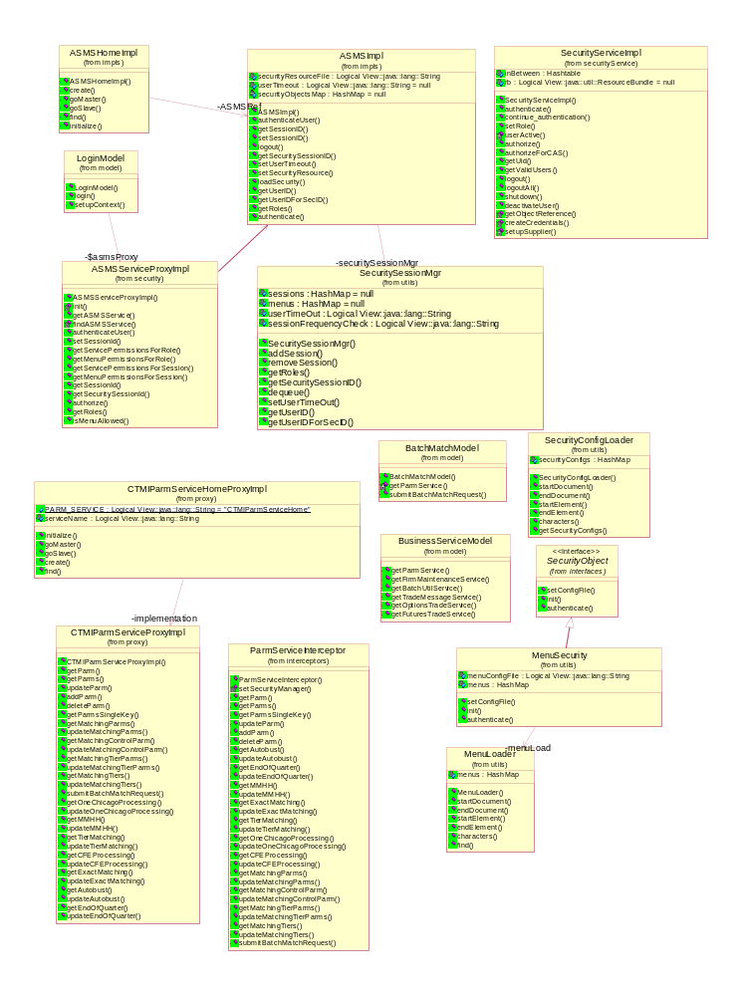

Sequence Diagram:

- User Authentication

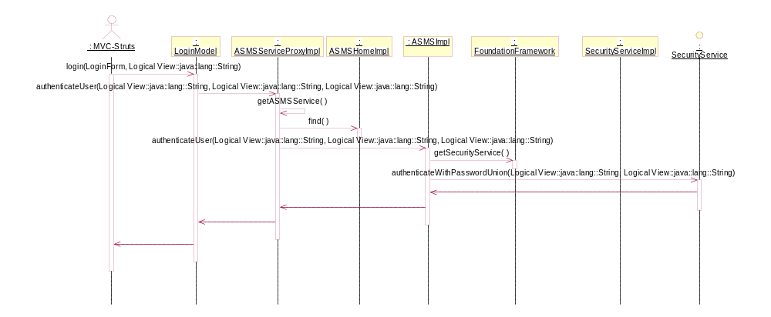

- Session Management

- Service Level Authorization
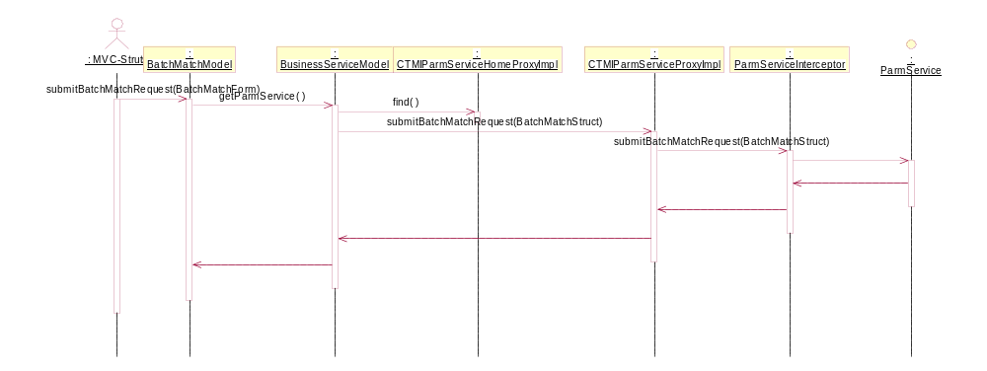

- Client Level Security

- User Maintenance

  - View Users

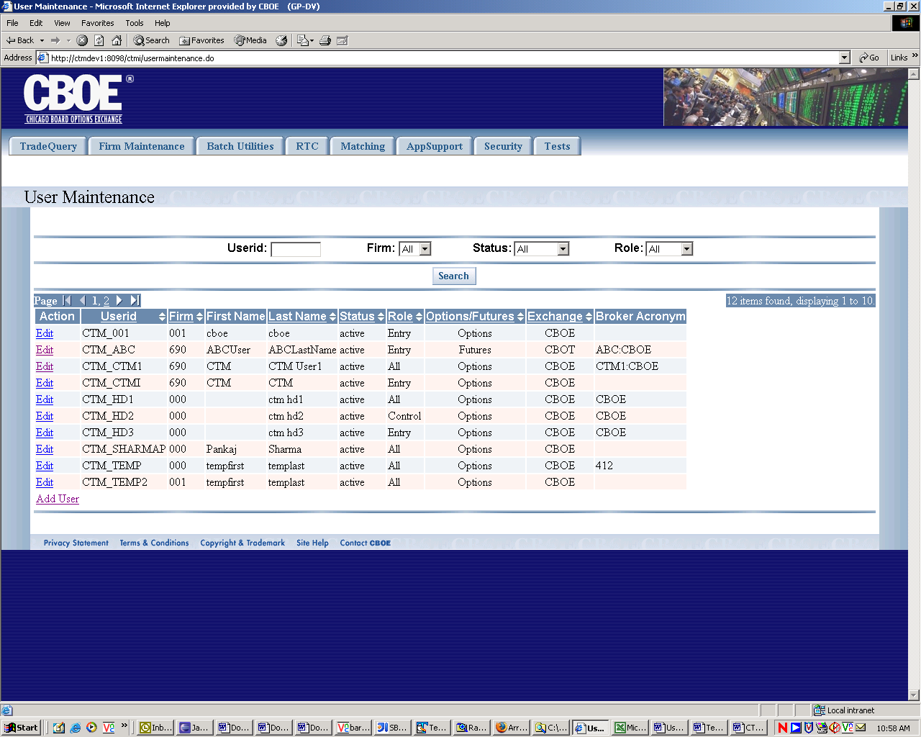

  - Add Users

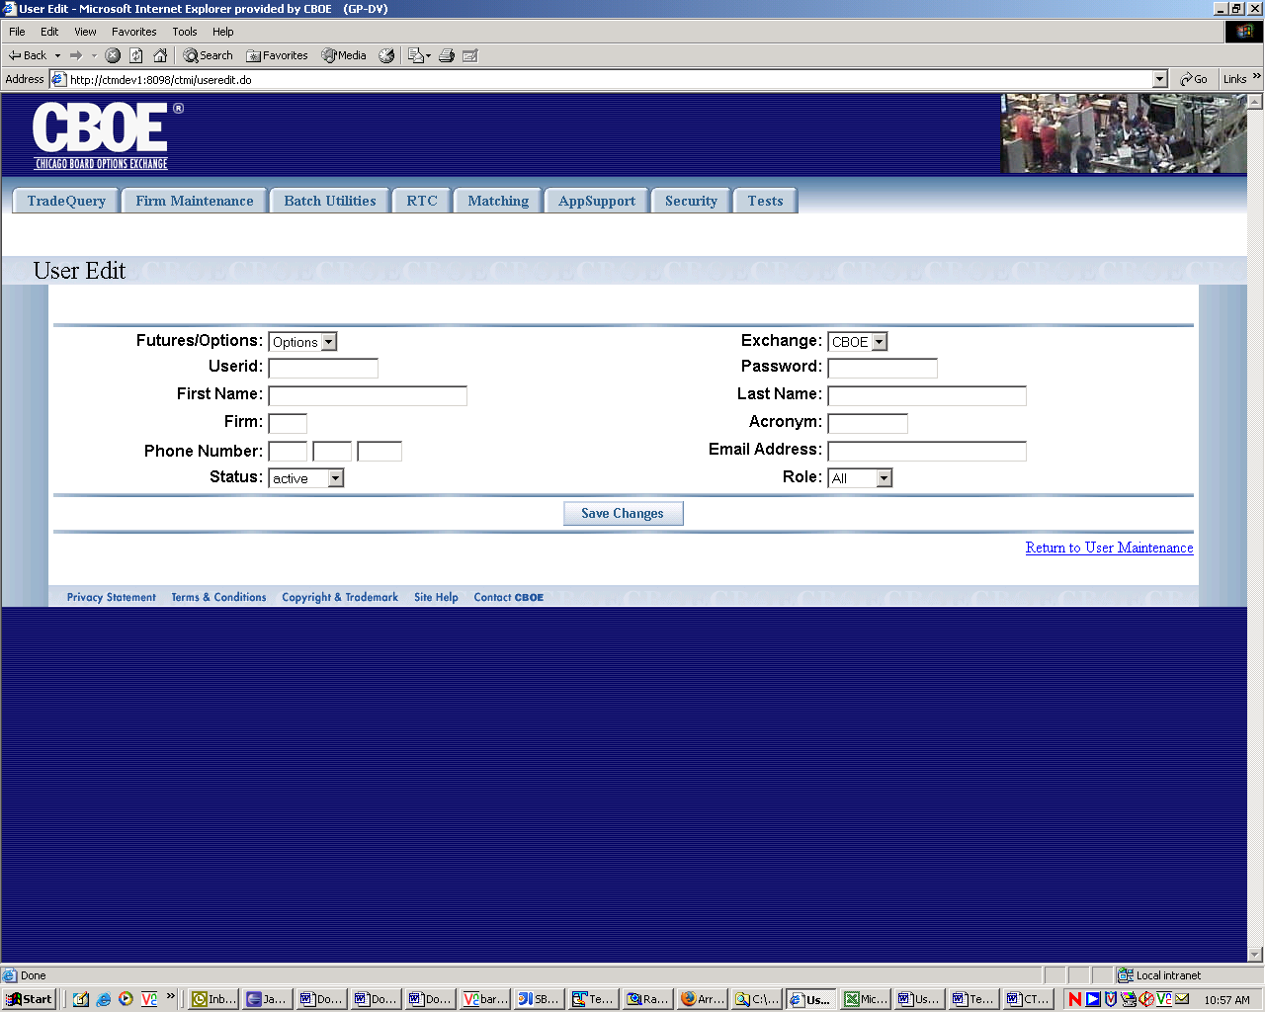

  - Edit Users

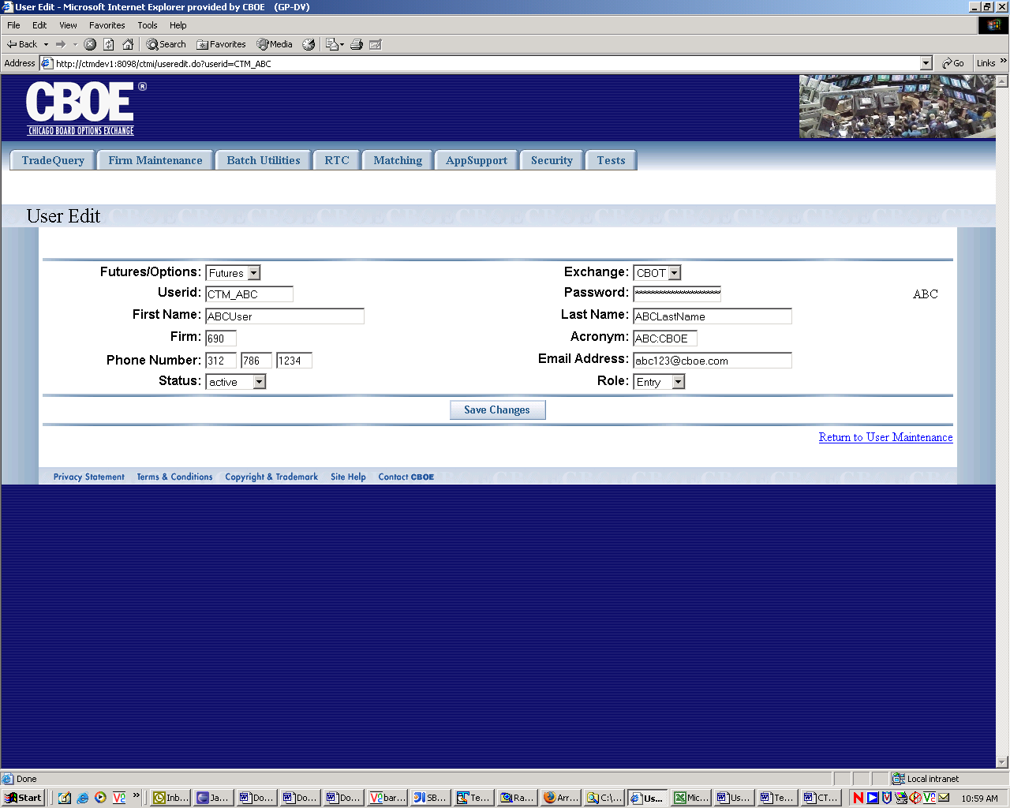

Implementation:
Service Interceptors:
ParmServiceInterceptor
FirmMaintenanceServiceInterceptor
OptionsTradeServiceInterceptor
FuturesTradeServiceInterceptor
TradeMessageServiceInterceptor
BatchUtilServiceInterceptor
UserMaintenanceServiceInterceptor

Makefiles -
.mk files -
CTMITemplate.txt -
Service Proxies:
ParmServiceProxyImpl
FirmMaintenanceServiceProxyImpl
OptionsTradeServiceProxyImpl
FuturesTradeServiceProxyImpl
TradeMessageServiceProxyImpl
BatchUtilServiceProxyImpl
UserMaintenanceServiceProxyImpl

Service Proxy Homes
ParmServiceHomeProxyImpl
FirmMaintenanceServiceHomeProxyImpl
OptionsTradeServiceHomeProxyImpl
FuturesTradeServiceHomeProxyImpl
TradeMessageServiceHomeProxyImpl
BatchUtilServiceHomeProxyImpl
UserMaintenanceServiceHomeProxyImpl

Integration to Model

Configuration:

ASMS.xml:
<?xml version="1.0" encoding="UTF-8"?>
<!DOCTYPE GlobalASMSHome SYSTEM "../dtd/ASMS.dtd">

<GlobalASMSHome>
<ASMSHomeImpl name="userSession">
<ASMSHomeImplProperties>
<userSessionTimeout>1600000</userSessionTimeout>
<sessionFrequencyCheck>53000</sessionFrequencyCheck>
<securityResource>../xml/SecurityConfig.xml</securityResource>
</ASMSHomeImplProperties>
</ASMSHomeImpl>
</GlobalASMSHome>

CTMIClientServer.xml:
<?xml version="1.0" encoding="UTF-8"?>
<!DOCTYPE GlobalFoundationFramework SYSTEM "../dtd/GenericServer.dtd">
<GlobalFoundationFramework>
<FoundationFramework name="CTMIClientServer">
<CoreService name="GlobalServerCoreService">
<CoreServiceProperties>
<orbServiceImpl value="com.cboe.infrastructureServices.orbService.OrbServicePOAImpl"/>
<orbServiceName>RootOnly</orbServiceName>
<commandCallbackServiceImpl value="com.cboe.infrastructureServices.systemsManagementService.CommandCallbackServiceSysManImpl"/>
<eventServiceImpl value="com.cboe.infrastructureServices.eventService.EventServiceTraderImpl"/>
<eventServiceName>DefaultServer</eventServiceName>
<traderServiceImpl value="com.cboe.infrastructureServices.traderService.TraderServiceImpl"/>
<traderServiceName>TraderServiceProperties</traderServiceName>
<loggingServiceImpl value="com.cboe.infrastructureServices.loggingService.LogServiceSMAImpl"/>
<loggingServiceName>CTMIClientServerClient</loggingServiceName>
<adminServiceImpl value="com.cboe.infrastructureServices.systemsManagementService.AdminServiceImpl"/>
<adminServiceName>Dynamic</adminServiceName>
<securityServiceImpl value="com.cboe.infrastructureServices.securityService.SecurityServiceImpl"/>
<securityServiceName>DefaultService</securityServiceName>
<persistenceServiceImpl value="com.cboe.infrastructureServices.persistenceService.PersistenceServiceImpl"/>
<persistenceServiceName>CtmiPersistenceService</persistenceServiceName>
<instrumentationServiceImpl value="com.cboe.infrastructureServices.instrumentationService.InstrumentationServiceImpl"/>
<instrumentationServiceName>DefaultService</instrumentationServiceName>
<sessionManagementServiceImpl value="com.cboe.infrastructureServices.sessionManagementService.SessionManagementServiceNullImpl"/>
<sessionManagementServiceName>DefaultService</sessionManagementServiceName>
<sessionManagementServiceImpl value="com.cboe.infrastructureServices.sessionManagementService.SessionManagementServiceNullImpl"/>
<sessionManagementServiceName>DefaultService</sessionManagementServiceName>
</CoreServiceProperties>
</CoreService>
<BOContainer name="general">
<BOContainerProperties>
<containerImpl implClassName="com.cboe.infrastructureServices.foundationFramework.BOContainer"/>
<persistentBrokerName brokerName="transient"/>
</BOContainerProperties>
<BOHome name="JettyServiceHome">
<BOHomeProperties>
<homeImpl>com.cboe.jetty.JettyServiceHomeImpl</homeImpl>
<managedResourceName>JettyServiceHomeImpl</managedResourceName>
</BOHomeProperties>
</BOHome>
<BOHome name="IORResolverFactoryInitializer">
<BOHomeProperties>
<homeImpl>com.cboe.server.util.IORResolverFactoryInitializer</homeImpl>
</BOHomeProperties>
</BOHome>
<BOHome name="CTMILoggingServiceHome">
<BOHomeProperties>
<homeImpl>com.cboe.ctmi.ctmiLoggingService.CTMILoggingServiceHomeImpl</homeImpl>
<managedResourceName>CTMILoggingServiceHome</managedResourceName>
</BOHomeProperties>
</BOHome>
<BOHome name="CTMILoggingAdminServiceHome">
<BOHomeProperties>
<homeImpl>com.cboe.ctmi.ctmiLoggingService.CTMILoggingAdminServiceHomeProxyImpl</homeImpl>
</BOHomeProperties>
<homeImpl>com.cboe.ctmi.ctmiLoggingService.CTMILoggingAdminServiceHomeProxyImpl</homeImpl>
</BOHomeProperties>
</BOHome>
<BOHome name="CTMILoggingAdminConsumerHome">
<BOHomeProperties>
<homeImpl>com.cboe.ctmi.consumers.eventChannel.LoggingAdminConsumerHomeEventImpl</homeImpl>
<managedResourceName>CTMILoggingAdminConsumerHome</managedResourceName>
</BOHomeProperties>
</BOHome>
<BOHome name="TradeMaintenanceServiceHome">
<BOHomeProperties>
<homeImpl>com.cboe.ctmi.tradeMaintenance.TradeMaintenanceServiceHomeProxyImpl</homeImpl>
</BOHomeProperties>
</BOHome>
<BOHome name="TradeMessageServiceHome">
<BOHomeProperties>
<homeImpl>com.cboe.ctmi.tradeMessage.TradeMessageServiceHomeProxyImpl</homeImpl>
</BOHomeProperties>
</BOHome>
<BOHome name="FuturesTradeServiceHome">
<BOHomeProperties>
<homeImpl>com.cboe.ctmi.futuresTrade.FuturesTradeServiceHomeProxyImpl</homeImpl>
</BOHomeProperties>
</BOHome>
<BOHome name="ParmServiceHome">
<BOHomeProperties>
<homeImpl>com.cboe.ctmi.parm.ParmServiceHomeProxyImpl</homeImpl>
</BOHomeProperties>
</BOHome>
<BOHome name="MatchingParmsServiceHome">
<BOHomeProperties>
<BOHome name="MatchingParmsServiceHome">
<BOHomeProperties>
<homeImpl>com.cboe.ctmi.matchingParms.MatchingParmsServiceHomeProxyImpl</homeImpl>
</BOHomeProperties>
</BOHome>
<BOHome name="FirmMaintenanceServiceHome">
<BOHomeProperties>
<homeImpl>com.cboe.ctmi.firmMaintenance.FirmMaintenanceServiceHomeProxyImpl</homeImpl>
</BOHomeProperties>
</BOHome>
<BOHome name="UserMaintenanceServiceHome">
<BOHomeProperties>
<homeImpl>com.cboe.ctmi.userMaintenance.UserMaintenanceServiceHomeProxyImpl</homeImpl>
</BOHomeProperties>
</BOHome>
<BOHome name="RtcServiceHome">
<BOHomeProperties>
<homeImpl>com.cboe.ctmi.rtc.RtcServiceHomeProxyImpl</homeImpl>
</BOHomeProperties>
</BOHome>
<BOHome name="ASMSHome">
<BOHomeProperties>
<homeImpl>com.cboe.bo.common.impls.ASMSHomeImpl</homeImpl>
<managedResourceName>userSession</managedResourceName>
</BOHomeProperties>
</BOHome>
<BOHome name="GlobalEventChannelHome">
<BOHomeProperties>
<homeImpl>com.cboe.consumers.eventChannel.EventChannelHomeImpl</homeImpl>
<managedResourceName>DefaultService</managedResourceName>
</BOHomeProperties>
</BOHome>
<BOHome name="BatchUtilServiceHome">
</BOHome>
<BOHome name="BatchUtilServiceHome">
<BOHomeProperties>
<homeImpl>com.cboe.ctmi.batchUtil.BatchUtilServiceHomeProxyImpl</homeImpl>
</BOHomeProperties>
</BOHome>
<BOHome name="OptionsTradeServiceHome">
<BOHomeProperties>
<homeImpl>com.cboe.ctmi.optionsTrade.OptionsTradeServiceHomeProxyImpl</homeImpl>
</BOHomeProperties>
</BOHome>
<BOHome name="FieldAuthorizationServiceHome">
<BOHomeProperties>
<homeImpl>com.cboe.ctmi.fieldAuthorization.FieldAuthorizationServiceHomeProxyImpl</homeImpl>
</BOHomeProperties>
</BOHome>
<BOHome name="CTMIParmServiceHome">
<BOHomeProperties>
<homeImpl>com.cboe.ctmi.businessServices.proxy.CTMIParmServiceHomeProxyImpl</homeImpl>
<managedResourceName>CTMIParmServiceHomeProxyImpl</managedResourceName>
<interceptorName>ParmServiceInterceptor</interceptorName>
<interceptorImpl>com.cboe.ctmi.interceptors.ParmServiceInterceptor</interceptorImpl>
</BOHomeProperties>
</BOHome>
<BOHome name="CTMIFirmMaintenanceServiceHome">
<BOHomeProperties>
<homeImpl>com.cboe.ctmi.businessServices.proxy.CTMIFirmMaintenanceServiceHomeProxyImpl</homeImpl>
<managedResourceName>CTMIFirmMaintenanceServiceHomeProxyImpl</managedResourceName>
<interceptorName>FirmMaintenanceServiceInterceptor</interceptorName>
<interceptorImpl>com.cboe.ctmi.interceptors.FirmMaintenanceServiceInterceptor</interceptorImpl>
<interceptorName>FirmMaintenanceServiceInterceptor</interceptorName>
<interceptorImpl>com.cboe.ctmi.interceptors.FirmMaintenanceServiceInterceptor</interceptorImpl>
</BOHomeProperties>
</BOHome>
<BOHome name="CTMIOptionsTradeServiceHome">
<BOHomeProperties>
<homeImpl>com.cboe.ctmi.businessServices.proxy.CTMIOptionsTradeServiceHomeProxyImpl</homeImpl>
<managedResourceName>CTMIOptionsTradeServiceHomeProxyImpl</managedResourceName>
<interceptorName>OptionsTradeServiceInterceptor</interceptorName>
<interceptorImpl>com.cboe.ctmi.interceptors.OptionsTradeServiceInterceptor</interceptorImpl>
</BOHomeProperties>
</BOHome>
<BOHome name="CTMIBatchUtilServiceHome">
<BOHomeProperties>
<homeImpl>com.cboe.ctmi.businessServices.proxy.CTMIBatchUtilServiceHomeProxyImpl</homeImpl>
<managedResourceName>CTMIBatchUtilServiceHomeProxyImpl</managedResourceName>
<interceptorName>BatchUtilServiceInterceptor</interceptorName>
<interceptorImpl>com.cboe.ctmi.interceptors.BatchUtilServiceInterceptor</interceptorImpl>
</BOHomeProperties>
</BOHome>
<BOHome name="CTMITradeMessageServiceHome">
<BOHomeProperties>
<homeImpl>com.cboe.ctmi.businessServices.proxy.CTMITradeMessageServiceHomeProxyImpl</homeImpl>
<managedResourceName>CTMITradeMessageServiceHomeProxyImpl</managedResourceName>
<interceptorName>TradeMessageServiceInterceptor</interceptorName>
<interceptorImpl>com.cboe.ctmi.interceptors.TradeMessageServiceInterceptor</interceptorImpl>
<interceptorName>TradeMessageServiceInterceptor</interceptorName>
<interceptorImpl>com.cboe.ctmi.interceptors.TradeMessageServiceInterceptor</interceptorImpl>
</BOHomeProperties>
</BOHome>
<BOHome name="CTMIRtcServiceHome">
<BOHomeProperties>
<homeImpl>com.cboe.ctmi.businessServices.proxy.CTMIRtcServiceHomeProxyImpl</homeImpl>
<managedResourceName>CTMIRtcServiceHomeProxyImpl</managedResourceName>
<interceptorName>RtcServiceInterceptor</interceptorName>
<interceptorImpl>com.cboe.ctmi.interceptors.RtcServiceInterceptor</interceptorImpl>
</BOHomeProperties>
</BOHome>
</BOContainer>
<FoundationFrameworkProperties>
<logServiceComponent value="CTMIClientServer"/>
<listOfHomes>
IORResolverFactoryInitializer,
GlobalEventChannelHome,
CTMILoggingServiceHome,
CTMILoggingAdminConsumerHome,
CTMILoggingAdminServiceHome,
ASMSHome,
JettyServiceHome,
TradeMaintenanceServiceHome,
TradeMessageServiceHome,
FuturesTradeServiceHome,
UserMaintenanceServiceHome,
FirmMaintenanceServiceHome,
ParmServiceHome,
MatchingParmsServiceHome,
RtcServiceHome,
BatchUtilServiceHome,
RtcServiceHome,
BatchUtilServiceHome,
OptionsTradeServiceHome,
FieldAuthorizationServiceHome,
CTMIParmServiceHome,
CTMIFirmMaintenanceServiceHome,
CTMIOptionsTradeServiceHome,
CTMIBatchUtilServiceHome,
CTMITradeMessageServiceHome,
CTMIRtcServiceHome
</listOfHomes>
<autoStart booleanValue="true"/>
<autoInit booleanValue="true"/>
<isMaster>true</isMaster>
<instrumentationEnabled booleanValue="true"/>
</FoundationFrameworkProperties>
<Application>
<ApplicationProperties>
<routeName>&lt;prefixRouteName&gt;</routeName>
<remoteRouteName>&lt;prefixRemoteRouteName&gt;</remoteRouteName>
</ApplicationProperties>
</Application>
</FoundationFramework>
</GlobalFoundationFramework>

SecurityConfig.xml:

<?xml version="1.0" encoding="UTF-8"?>
<SecurityConfig>
<security name="MenuSecurity" configFile="../xml/menu-config.xml" className="com.cboe.bo.common.utils.MenuSecurity"/>
</SecurityConfig>

Menu-config.xml:

<?xml version="1.0" encoding="UTF-8" ?>

<MenuConfig>

<Displayers>
<Displayer name="DropDown"
type="net.sf.navigator.displayer.DropDownMenuDisplayer"/>
<Displayer name="Simple"
type="net.sf.navigator.displayer.SimpleMenuDisplayer"/>
<Displayer name="CoolMenu"
type="net.sf.navigator.displayer.CoolMenuDisplayer"/>
<Displayer name="CoolMenu4"
type="net.sf.navigator.displayer.CoolMenuDisplayer4"/>
<Displayer name="MenuForm"
type="net.sf.navigator.example.PermissionsFormMenuDisplayer"/>
<Displayer name="ListMenu"
type="net.sf.navigator.displayer.ListMenuDisplayer"/>
<Displayer name="TabbedMenu"
type="net.sf.navigator.displayer.TabbedMenuDisplayer"/>
<Displayer name="Velocity"
type="net.sf.navigator.displayer.VelocityMenuDisplayer"/>
</Displayers>

<Menus>

<!-- Menu for CTM-I -->
<Menu name="CTMIHome" title="Home" location="login.jsp" />
<Menu name="Login" title="Login">
<Item name="Login" title="Login" location="login.do" roles="CTM_Firm_Options_Root,CTM_Firm_Options_Clerk,CTM_Root,CTM_System,CTM_Help_Desk" />
</Menu>
<Menu name="TradeQuery" title="TradeQuery" location="#" roles="CTM_Firm_Options_Admin,CTM_Firm_Options_Clerk,CTM_Firm_Futures_Root,CTM_Firm_Futures_Clerk,CTM_Root,CTM_System,CTM_Help_Desk" onmouseover="displayMenu('TradeQuery')">
<Item name="TradeQuery" title="TradeQuery" location="tradequery.do" roles="CTM_Firm_Options_Clerk,CTM_Root,CTM_System,CTM_Help_Desk"/>
<Item name="TradeMessage" title="Trade Message" location="trademessage.do" roles="CTM_Firm_Options_Admin,CTM_Firm_Options_Clerk,CTM_Root,CTM_System,CTM_Help_Desk"/>
<Item name="FuturesTradeQuery" title="Futures Trade Query" location="futurestradequery.do" roles="CTM_Firm_Futures_Root,CTM_Firm_Futures_Clerk,CTM_Root,CTM_System,CTM_Help_Desk"/>
<Item name="TradeEntry" title="Trade Entry" location="tradeentry.do" roles="CTM_Firm_Options_Clerk,CTM_Root,CTM_System,CTM_Help_Desk"/>
</Menu>
<Menu name="AppSupport" title="AppSupport" location="#" roles="CTM_Root,CTM_System,CTM_Help_Desk" onmouseover="displayMenu('AppSupport')">
<Item name="Parm Browse" title="Parm Browse" location="parmbrowse.do" roles="CTM_Root,CTM_System,CTM_Help_Desk"/>
<!-- TODO: roles for Log Control not yet determined -->
<Item name="Log Control" title="Log Control" location="logcontrol.do" roles="CTM_Root,CTM_System,CTM_Help_Desk"/>
<Item name="AuditQuery" title="Audit Query" location="auditquery.do" roles="CTM_Root,CTM_System,CTM_Help_Desk"/>
<Item name="InternalSwitchMaintenance" title="Internal Switch Maintenance" location="internalswitchmaintenance.do" roles="CTM_Root,CTM_System"/>
<!-- TODO: roles for Back-Door Futures Delete not yet determined -->
<Item name="Back-Door Futures Delete" title="Back-Door Futures Delete" location="backdoorfuturesdelete.do" roles="CTM_Root,CTM_System,CTM_Help_Desk"/>
<!-- TODO: roles for Back-Door Fuo not yet determined -->
<Item name="Back-Door Fuo" title="Back-Door Fuo" location="backdoorfuo.do" roles="CTM_Root,CTM_System,CTM_Help_Desk"/>
<!-- TODO: roles for Field Security Maintenance not yet determined -->
<Item name="FieldSecurityMaintenance" title="Field Security Maintenance" location="fieldsecuritymaintenance.do" roles="CTM_Root,CTM_System,CTM_Help_Desk"/>
<Item name="Range Delete" title="Range Delete" location="rangedelete.do" roles="CTM_Root,CTM_Help_Desk"/>
<!-- TODO: roles for Role Maintenance not yet determined -->
<Item name="RoleMaintenance" title="Role Maintenance" location="rolemaintenance.do" roles="CTM_Root,CTM_System,CTM_Help_Desk"/>
</Menu>
<Menu name="RTC" title="RTC" location="#" roles="CTM_Root,CTM_System,CTM_Help_Desk" onmouseover="displayMenu('RTC')">
<Item name="DropCopy" title="Drop Copy" location="dropcopy.do" roles="CTM_Root,CTM_System,CTM_Help_Desk"/>
<Item name="TcpipResend" title="TCP/IP Re-Send" location="tcpipresend.do" roles="CTM_Root,CTM_System,CTM_Help_Desk"/>
</Menu>
<Menu name="Matching" title="Matching" location="#" roles="CTM_Root,CTM_System,CTM_Help_Desk,CTM_Firm_Options_Root" onmouseover="displayMenu('Matching')">
<Item name="StatusDisplay" title="Status Display" location="statusdisplay.do" roles="CTM_Root,CTM_System,CTM_Help_Desk,CTM_Firm_Options_Root"/>
<Item name="TierMatch" title="Tier Match" location="tiermatch.do" roles="CTM_Root,CTM_System,CTM_Help_Desk,CTM_Firm_Options_Root"/>
<Item name="ControlUpdate" title="Control Update" location="controlupdate.do" roles="CTM_Root,CTM_System,CTM_Help_Desk,CTM_Firm_Options_Root"/>
<Item name="BatchMatch" title="Batch Match" location="batchmatch.do" roles="CTM_Root,CTM_System,CTM_Help_Desk,CTM_Firm_Options_Root"/>
</Menu>
<Menu name="FirmMaintenance" title="Firm Maintenance" location="#" roles="CTM_Firm_Options_Root,CTM_Firm_Options_Admin,CTM_Firm_Options_Clerk,CTM_Firm_Futures_Root,CTM_Firm_Futures_Admin,CTM_Root,CTM_System,CTM_Help_Desk" onmouseover="displayMenu('Firm Maintenance')">
<Item name="FirmAuthorization" title="Firm Authorization" location="firmauthorization.do" roles="CTM_Firm_Options_Root,CTM_Firm_Options_Admin,CTM_Firm_Futures_Root,CTM_Firm_Futures_Admin,CTM_Root,CTM_System,CTM_Help_Desk"/>
<Item name="FirmContactList" title="Firm Contact List" location="firmcontactlist.do" roles="CTM_Firm_Options_Root,CTM_Firm_Options_Admin,CTM_Firm_Options_Clerk,CTM_Root,CTM_System,CTM_Help_Desk"/>
<Item name="FirmTcpIpPassword" title="Firm TCP/IP Socket Password" location="firmtcpippassword.do" roles="CTM_Firm_Options_Root,CTM_Root,CTM_System"/>
<!-- TODO: roles for BrokerContactList not yet determined -->
<Item name="BrokerContactList" title="Broker Contact List" location="brokercontactlist.do" roles="CTM_Root,CTM_System,CTM_Help_Desk"/>
<!-- TODO: roles for FirmRoleMaintenance not yet determined -->
<Item name="FirmRoleMaintenance" title="Firm Role Maintenance" location="firmrolemaintenance.do" roles="CTM_Root,CTM_System,CTM_Help_Desk"/>
<Item name="FirmStatistics" title="Firm Statistics" location="firmstatistics.do" roles="CTM_Firm_Options_Root,CTM_Firm_Options_Admin,CTM_Firm_Options_Clerk,CTM_Root,CTM_System,CTM_Help_Desk"/>
<Item name="OrsCorrespondentConversion" title="ORS Correspondent Conversion" location="orscorrespondentconversion.do" roles="CTM_Firm_Options_Root,CTM_Firm_Options_Admin,CTM_Root,CTM_Help_Desk"/>
<Item name="TradingGroup" title="Trading Group" location="tradinggroup.do" roles="CTM_Firm_Options_Root,CTM_Firm_Options_Admin,CTM_Firm_Futures_Root,CTM_Firm_Futures_Admin,CTM_Root,CTM_System,CTM_Help_Desk"/>
</Menu>
<Menu name="BatchUtilities" title="Batch Utilities" location="#" roles="CTM_Root,CTM_Help_Desk" onmouseover="displayMenu('Batch Utilities')">
<Item name="WireAuthorization" title="Wire Authorizations" location="wireAuthorization.do" roles="CTM_Root,CTM_Help_Desk"/>
<Item name="BatchLoadInformation" title="Batch Load" location="batchLoadInformation.do" roles="CTM_Root,CTM_Help_Desk"/>
<Item name="BatchDelete" title="Batch Delete" location="batchdelete.do" roles="CTM_Root,CTM_Help_Desk"/>
</Menu>
<Menu name="Security" title="Security" location="#" roles="CTM_Firm_Options_Root,CTM_Firm_Futures_Root,CTM_Root,CTM_System" onmouseover="displayMenu('Security')">
<Item name="UserMaintenance" title="User Maintenance" location="usermaintenance.do" roles="CTM_Firm_Options_Root,CTM_Firm_Futures_Root,CTM_Root,CTM_System"/>
</Menu>
<!-- TODO: remove menu Tests -->
<Menu name="Tests" title="Tests" location="#" roles="CTM_Root,CTM_System,CTM_Help_Desk" onmouseover="displayMenu('Tests')">
<Item name="FieldAuthTest" title="Field Authorization Test" location="fieldAuthTest.do" roles="CTM_Root,CTM_System,CTM_Help_Desk"/>
</Menu>

</Menus>

<!-- Keep this list alphabetical to make it easier to maintain -->
<Page>
<Item name="PageAuditQuery" location="/ctmi/auditquery.do" roles="CTM_Root,CTM_System,CTM_Help_Desk" />
<Item name="PageBackDoorFuturesDelete" location="/ctmi/backdoorfuturesdelete.do" roles="CTM_Root,CTM_System,CTM_Help_Desk" />
<Item name="PageBackDoorFuo" location="/ctmi/backdoorfuo.do" roles="CTM_Root,CTM_System,CTM_Help_Desk" />
<Item name="PageBatchDelete" location="/ctmi/batchdelete.do" roles="CTM_Root,CTM_Help_Desk" />
<Item name="PageBatchMatch" location="/ctmi/batchmatch.do" roles="CTM_Root,CTM_System,CTM_Help_Desk" />
<Item name="PageBrokerContactList" location="/ctmi/brokercontactlist.do" roles="CTM_Root,CTM_System,CTM_Help_Desk" />
<!-- TODO: No corresponding Menu for Broker Role Display -->
<Item name="PageBrokerRoleDisplay" location="/ctmi/brokerroledisplay.do" roles="CTM_Root,CTM_System,CTM_Help_Desk" />
<Item name="PageControlUpdate" location="/ctmi/controlupdate.do" roles="CTM_Root,CTM_System,CTM_Help_Desk" />
<!-- TODO: No corresponding Menu for Drop Copy Add -->
<Item name="PageDropCopyAdd" location="/ctmi/dropcopyadd.do" roles="CTM_Root,CTM_System,CTM_Help_Desk" />
<Item name="PageDropCopy" location="/ctmi/dropcopy.do" roles="CTM_Root,CTM_System,CTM_Help_Desk" />
<Item name="PageFieldSecurityMaintenance" location="/ctmi/fieldsecuritymaintenance.do" roles="CTM_Root,CTM_System,CTM_Help_Desk" />
<Item name="PageFirmAuthorization" location="/ctmi/firmauthorization.do" roles="CTM_Firm_Options_Root,CTM_Firm_Options_Admin,CTM_Firm_Futures_Root,CTM_Firm_Futures_Admin,CTM_Root,CTM_System,CTM_Help_Desk" />
<Item name="PageFirmContactList" location="/ctmi/firmcontactlist.do" roles="CTM_Firm_Options_Root,CTM_Firm_Options_Admin,CTM_Firm_Options_Clerk,CTM_Root,CTM_System,CTM_Help_Desk" />
<Item name="PageFirmTcpIpPassword" location="/ctmi/firmtcpippassword.do" roles="CTM_Firm_Options_Root,CTM_Root,CTM_System" />
<Item name="PageFirmStatistics" location="/ctmi/firmstatistics.do" roles="CTM_Firm_Options_Root,CTM_Firm_Options_Admin,CTM_Firm_Options_Clerk,CTM_Root,CTM_System,CTM_Help_Desk" />
<Item name="PageFirmRoleMaintenance" location="/ctmi/firmrolemaintenance.do" roles="CTM_Root,CTM_System,CTM_Help_Desk" />
<!-- TODO: No corresponding Menu for Firm Role Maintenance Search -->
<Item name="PageFirmRoleMaintenanceSearch" location="/ctmi/firmrolemaintenancesearch.do" roles="CTM_Root,CTM_System,CTM_Help_Desk" />
<!-- TODO: No corresponding Menu for Futures Trade Allocation -->
<Item name="PageFuturesTradeAllocation" location="/ctmi/futurestradeallocation.do" roles="CTM_Root,CTM_System,CTM_Help_Desk" />
<!-- TODO: No corresponding Menu for Futures Trade Correction -->
<Item name="PageFuturesTradeCorrection" location="/ctmi/futurestradecorrection.do" roles="CTM_Root,CTM_System,CTM_Help_Desk" />
<Item name="PageFuturesTradeQuery" location="/ctmi/futurestradequery.do" roles="CTM_Firm_Futures_Root,CTM_Firm_Futures_Clerk,CTM_Root,CTM_System,CTM_Help_Desk" />
<!-- TODO: No corresponding Menu for Futures Trade Release -->
<Item name="PageFuturesTradeRelease" location="/ctmi/futurestraderelease.do" roles="CTM_Root,CTM_System,CTM_Help_Desk" />
<Item name="PageInternalSwitchMaintenance" location="/ctmi/internalswitchmaintenance.do" roles="CTM_Root,CTM_System" />
<Item name="PageLogControl" location="/ctmi/logcontrol.do" roles="CTM_Root,CTM_System,CTM_Help_Desk" />
<!-- TODO: No corresponding Menu for Message Maintenance -->
<Item name="PageMessageMaintenance" location="/ctmi/messagemaintenance.do" roles="CTM_Root,CTM_System,CTM_Help_Desk" />
<!-- TODO: No corresponding Menu for Modify User Role -->
<Item name="PageModifyUserRole" location="/ctmi/modifyuserrole.do" roles="CTM_Root,CTM_System,CTM_Help_Desk" />
<Item name="PageOrsCorrespondentConversion" location="/ctmi/orscorrespondentconversion.do" roles="CTM_Firm_Options_Root,CTM_Firm_Options_Admin,CTM_Root,CTM_Help_Desk" />
<Item name="PageParmBrowse" location="/ctmi/parmbrowse.do" roles="CTM_Root,CTM_System,CTM_Help_Desk" />
<!-- TODO: No corresponding Menu for Parm Generic Edit -->
<Item name="PageParmEdit" location="/ctmi/parmgenericedit.do" roles="CTM_Root,CTM_System,CTM_Help_Desk" />
<Item name="PageRangeDelete" location="/ctmi/rangedelete.do" roles="CTM_Root,CTM_Help_Desk" />
<Item name="PageRoleMaintenance" location="/ctmi/rolemaintenance.do" roles="CTM_Root,CTM_System,CTM_Help_Desk" />
<!-- TODO: No corresponding Menu for Role Maintenance Search -->
<Item name="PageRoleMaintenanceSearch" location="/ctmi/rolemaintenancesearch.do" roles="CTM_Root,CTM_System,CTM_Help_Desk" />
<Item name="PageStatusDisplay" location="/ctmi/statusdisplay.do" roles="CTM_Root,CTM_System,CTM_Help_Desk" />
<Item name="PageTcpipResend" location="/ctmi/tcpipresend.do" roles="CTM_Root,CTM_Help_Desk" />
<Item name="PageTierMatch" location="/ctmi/tiermatch.do" roles="CTM_Root,CTM_System,CTM_Help_Desk" />
<!-- TODO: No corresponding Menu for Trade Correction -->
<Item name="PageTradeCorrection" location="/ctmi/tradecorrection.do" roles="CTM_Root,CTM_System,CTM_Help_Desk" />
<Item name="PageTradeEntry" location="/ctmi/tradeentry.do" roles="CTM_Firm_Options_Root,CTM_Firm_Options_Clerk,CTM_Root,CTM_System,CTM_Help_Desk" />
<!-- TODO: No corresponding Menu for Trade Allocation -->
<Item name="PageTradeAllocation" location="/ctmi/tradeallocation.do" roles="CTM_Root,CTM_System,CTM_Help_Desk" />
<Item name="PageTradeMessage" location="/ctmi/trademessage.do" roles="CTM_Firm_Options_Root,CTM_Firm_Options_Admin,CTM_Firm_Options_Clerk,CTM_Root,CTM_System,CTM_Help_Desk" />
<Item name="PageTradeQuery" location="/ctmi/tradequery.do" roles="CTM_Firm_Options_Root,CTM_Firm_Options_Clerk,CTM_Root,CTM_System,CTM_Help_Desk" />
<Item name="PageTradingGroup" location="/ctmi/tradinggroup.do" roles="CTM_Firm_Options_Root,CTM_Firm_Options_Admin,CTM_Firm_Futures_Root,CTM_Firm_Futures_Admin,CTM_Root,CTM_System,CTM_Help_Desk" />
<!-- TODO: No corresponding Menu for User Edit -->
<Item name="PageUserEdit" location="/ctmi/useredit.do" roles="CTM_Firm_Options_Root,CTM_Firm_Futures_Root,CTM_Root,CTM_System,CTM_Help_Desk" />
<Item name="PageUserMaintenance" location="/ctmi/usermaintenance.do" roles="CTM_Firm_Options_Root,CTM_Firm_Futures_Root,CTM_Root,CTM_System" />
<Item name="PageWireAuthorization" location="/ctmi/wireAuthorization.do" roles="CTM_Root,CTM_Help_Desk" />
<Item name="PageBatchLoadInformation" location="/ctmi/batchLoadInformation.do" roles="CTM_Root,CTM_Help_Desk" />
<Item name="PageFieldAuthTest" location="/ctmi/fieldAuthTest.do" roles="CTM_Root,CTM_System,CTM_Help_Desk" />
</Page>

</MenuConfig>

Deployment:
Environment:
Standard Web server Deployment

Components:
Web Server Package – CTMI_ClientServer
Jar Files:
/vobs/cboe/CTMI_ClientServer/classes:
/vobs/cboe/BOCommon/release/BOCommon_idl.jar:
/vobs/cboe/BOCommon/release/BOCommon_interfaces.jar:
/vobs/dte/FoundationFramework/release/jars/FoundationFramework.jar:
/vobs/cboe/CTMI_ClientServer/lib/struts.jar:
/vobs/cboe/CTMI_Common/classes/interfaces/CTMICommon_interfaces.jar:
/vobs/cboe/CTMI_Common/classes/impls/CTMICommon_impls.jar:
/vobs/cboe/CTMI_Common/idl/idl_java/classes/CTMI_Common_idl.jar:
/vobs/cboe/CTMI_ApplicationServer/idl/idl_java/classes/CTMIApplicationServer_idl.jar:
/vobs/cboe/CTMI_ApplicationServer/classes/interfaces/CTMIApplicationServer_interfaces.jar:
/vobs/cboe/CTMI_ApplicationServer/classes/impls/CTMIApplicationServer_impls.jar:
/vobs/dte/tools/Jetty/Jetty-4.2.14/lib/javax.servlet.jar:
/vobs/dte/common/release/jars/common.jar:
/vobs/cboe/CTMI_ClientServer/Web/WEB-INF/lib/displaytag-1.0.jar:
/vobs/cboe/CTMI_ClientServer/Web/WEB-INF/lib/Struts-Layout.jar:
/vobs/dte/SecurityService/release/jars/SecurityServiceIDL.jar:
/vobs/dte/InfraVerity/release/jars/InfraVerityIDLClasses.jar:
/vobs/dte/domain/release/domain_impls.jar:
/vobs/dte/client/release/client_idl.jar:
/vobs/dte/CommonFacilities/release/CommonFacilities.jar:
/vobs/cboe/ctm/CTM/release/CTMIDL.jar:
/vobs/cboe/ctm/CTM/release/CTM.jar:
/vobs/cboe/CTMI_ApplicationServer/lib/JAMon.jar:
/vobs/dte/objectwave/release/objectwave.jar:
/vobs/cboe/CTMI_Common/templates:
/vobs/cboe/CTMI_ClientServer/Web/WEB-INF/lib/struts-menu-2.3a.jar:
/vobs/cboe/CTMI_ClientServer/lib/commons-logging.jar

XML / DTD files:

Script Files:

Test Plans:
Test environment:

Test Cases:

